

MODULE: Business Analysis 3.2

MODULE CODE: AIBUY3A

GROUP NAME: AI Intergration Into Healthcare

Due DATE: 2 November 2026

MODULE LECTURER: Malefetsane Matsela

GROUP MEMBERS:
Student Number | Initials | Surname | Group code |   Signature
240900138 | T.K | Mbhokota
223261351 | S.C | Mahlaule |  | 
223100846 | F | Ngonyama | 
223553921 | N.M | Makoko | 
224879812 | A | Moshoadiba |  | 
223328480 | O | Hlungwani |  | 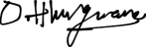
240829735 | NE | MHLONGO |  |   
240219708 | O | Mthombeni

Table Of Contents
Background…………………………………………………… 3
AI Solution…………………………………………………….. 3
Business Objectives………………………………………….. 4,5 &6
Problem Definition……………………………………………. 6 &7
Poster………………………………………………………….. 8
Machine Learning Approach…………………………………. 9
Data ……………………………………………………………. 10
Model…………………………………………………………… 11
Time Series Analysisi on data……………………………….. 12
Solution Techniques ………………………………………….. 12
Natural Language Processing, Speech recognition or synthesis 13
Deep Learning………………………………………………… 13&14
Other feartures:(Chatbot/Softbot) …………………………… 14
Grammar Report ……………………………………………… 15&16
Code …………………………………………………………… 17,18,19&20

Background
Every day, doctors are expected to remember thousands of medical conditions, drug interactions, and new research papers while treating patients with long, complicated medical histories. Because human memory has limits and hospital visits are often short, it is easy to miss rare side effects, tiny details buried in old medical notes, or unusual treatment options. This often leads to unexpected health complications or missed diagnoses that could have been prevented. As medical information grows faster than anyone can keep up with, standard healthcare needs a better way to check all the data quickly so doctors and medical students can catch these hidden risks before they harm a patient. That’s where AI Integration Into Healthcare enters.

AI Solution
This AI solution works like a smart assistant built directly into the hospital's computer system, reading through a patient's entire medical record—including past lab results, doctor notes, and genetic details. It instantly compares this history against global medical research, clinical trials, and drug databases to catch things a human might miss. Instead of just showing standard treatments, it organizes results into simple lists that highlight normal choices alongside rare, less than 1% chance risks or alternative options, complete with links to the medical studies behind them. This gives doctors and students a clear, proactive warning system to help them make safer decisions and prevent unexpected complications before they happen.

Business Objectives
- Business Background
Hospitals and healthcare systems around the world face a serious problem with preventable medical errors, unexpected complications, and missed diagnoses. While doctors are highly trained, they are often overworked and physically cannot read through every single page of a patient's long medical history or keep up with millions of global medical studies. Important details—like a rare drug reaction or an unusual condition buried in old lab reports—get overlooked simply because human memory and time have limits. This causes patients to suffer from unexpected side effects, leads to longer hospital stays, and costs healthcare providers millions of dollars in preventable emergency car

- Business Objectives
The main goal of this project is to build an intelligent assistant that helps healthcare teams make safer, faster, and more accurate decisions. First, the system aims to reduce unexpected medical complications by scanning patient histories to flag every possible treatment risk, including rare, less than 1% chance edge cases. Second, it aims to save clinicians time by automatically summarizing complex patient files so they can focus more on direct patient care. Third, it aims to train new doctors, nurses, and medical students on how to use modern predictive technology responsibly in their daily work.

- Business Success Criteria
The project will be judged a success if it achieves measurable improvements in patient safety, system efficiency, and user adoption. Specifically, the project targets a 20% to 25% drop in unexpected adverse drug events and medical complications within the first year of rollout. Operationally, it must reduce the time physicians spend manually reviewing past medical records by at least 30%. Finally, the system must achieve an 80% or higher satisfaction and trust rating from doctors and medical staff, proving that it genuinely helps their daily workflow without causing frustration or confusion.

- Requirements, Constraints, and Risks
To work properly, the system requires a direct connection to hospital electronic records, the ability to read messy handwritten or typed doctor notes, and a clear user interface that separates standard treatments from rare risks, with direct links to scientific research. However, the project faces strict constraints, including strict compliance with data privacy laws like HIPAA and GDPR, tight hospital IT budgets, and the requirement that the tool must work inside existing hospital software without slowing down system speed. Key risks include alert fatigue—where doctors ignore warnings if the system sends too many notifications—as well as potential data privacy breaches and the danger of the AI relying on incomplete or inaccurate patient history records.

- Tools and Techniques

To solve this problem safely and accurately, the project uses a combination of modern artificial intelligence techniques. Natural Language Processing tools like BioBERT are used to read and understand unstructured text, such as past doctor notes and clinical letters. A hybrid model combining Knowledge Graphs with Retrieval-Augmented Generation (RAG) acts as the reasoning engine, cross-referencing patient data against up-to-date global medical journals and drug registries to catch rare edge cases while avoiding made-up answers. Finally, standardized health data connection tools, known as FHIR APIs, allow the entire system to run smoothly inside existing hospital software like Epic or Cerner without requiring medical staff to switch between different applications.

Problem Definition
Healthcare practitioners usually have difficulties with going through numerous patient records, recognizing possible medication interactions and staying updated on new discoveries in medicine. Key data like patient’s history of adverse reactions to certain drugs, allergies, abnormal lab test results and unusual diseases can go unnoticed due to the lack of consultation time and the complexity of patients medical history. All of these mistakes can lead to wrong treatment choices, complications, delays in diagnosing the patient and hospitalization for a longer period of time. Conventional ways of analyzing medical data may not always help healthcare practitioners to quickly recognize the risk factors.
The suggested problem is expected to be solved through AI Integration Into Healthcare, which will involve development of a smart healthcare assistant programmed in Python language. The software is going to use supervised machine learning to analyze data about past and current patients conditions and find patterns indicating possible risks and effects of the treatment. NLP technology will allow extraction of necessary data from clinical notes whereas the medical knowledge database and retrieval system will deliver additional information taken from medical literature, clinical guidelines and drug databases. Potential risks and treatment considerations will be indicated by the system.
This solution is applicable to the concept of 4IR due to the use of artificial intelligence, machine learning, and data analytics within the healthcare services domain. It seeks to promote early risk assessment, minimize the review of medical files, and help healthcare practitioners make wise decisions. However, it should be noted that this platform will not take over the work of a physician or make any decisions on treatment on its own.

Poster
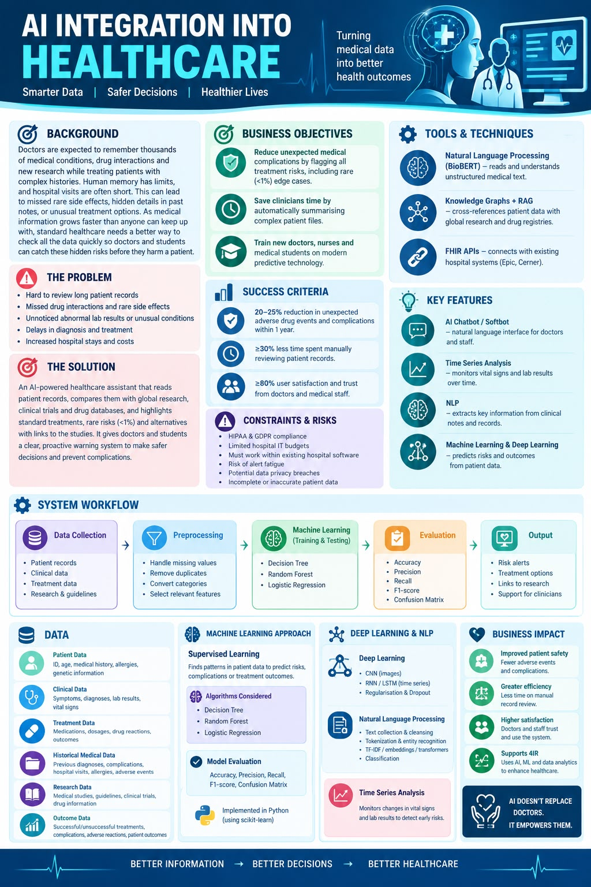

Machine Learning Approach
The proposed system will use Supervised Machine Learning because the model will be trained using historical patient data with known diagnoses, treatments, and outcomes. The main purpose of the machine learning approach is to identify patterns in patient information and predict possible medical risks, complications, or treatment-related outcomes. The system will support healthcare professionals by providing relevant information when reviewing a patient's medical history.
The first step will be data collection, where relevant historical patient records will be collected, including medical history, symptoms, laboratory results, diagnoses, medications, and treatment outcomes. The data will then be preprocessed by handling missing values, removing duplicate or incorrect records, and converting categorical information into a suitable format. Feature selection will then be performed to identify the most relevant patient information that can contribute to identifying medical risks and treatment outcomes.
The dataset will be divided into training and testing data. The training data will be used to teach the machine learning model, while the testing data will be used to evaluate how well the model performs on previously unseen information. Classification algorithms such as Decision Tree, Random Forest, and Logistic Regression will be considered because the system needs to classify possible medical outcomes. The selected model will be trained using the prepared historical patient data.
The model will be evaluated using accuracy, precision, recall and a confusion matrix to determine how accurately it identifies possible outcomes. If necessary, the model can be improved by adjusting its parameters and selecting more relevant features. Once the model has been evaluated, it can analyse new patient information and identify possible risks or outcomes based on patterns learned from historical data.
The trained machine learning model will form part of the AI healthcare assistant and provide supporting information to healthcare professionals.

The system will help highlight possible risks and treatment-related information, while the final clinical decision will remain with the qualified healthcare professional.

Data
The AI system will require relevant and reliable healthcare data to train, test, and operate the machine learning model. The data will include patient data such as patient ID, age, medical history, allergies, and genetic information. Clinical data will include symptoms, diagnoses, laboratory results, vital signs, and other clinical observations. This information will provide the model with the patient's medical background needed to identify relevant patterns.
The system will also require treatment data, including medications, previous treatments, dosages, drug reactions, and treatment outcomes. Historical medical data will include previous diagnoses, complications, hospital visits, allergies, and adverse medical events. This historical information is important because it allows the machine learning model to learn from previous patient cases and identify patterns that may indicate possible risks.
The system will also use research data, including medical studies, clinical guidelines, clinical trials, and drug information. This information will support the AI assistant when providing healthcare professionals with relevant medical information. Outcome data such as successful treatments, unsuccessful treatments, complications, adverse reactions, and patient outcomes will also be required. These outcomes provide labelled information that can be used for supervised machine learning.
Before the data is used, it will go through data preprocessing. Missing values will be identified and handled, duplicate or incorrect records will be removed, and categorical data will be converted into a suitable format for machine learning. Relevant features will then be selected, and the dataset will be divided into training and testing data. Appropriate privacy and security measures will also be applied because healthcare data contains sensitive patient information.

Model:
AI will help doctors look at a patient’s records and spot good treatment choices and hidden health dangers. AI will read a medical database that holds details like age, past illnesses, symptoms, allergies, medicines, lab tests, how the treatment worked, and other medical facts. A supervised machine learning model can be built with labelled old medical data to find patterns linked to specific illnesses and to forecast the chance of chosen problems happening. AI will mix these forecasts with a lookup tool that pulls up proven treatment options, warnings, and other choices for doctors to check.
For the AI learning part, a simple Decision Tree or Random Forest can be used to predict a clinical result, like whether a patient might suffer a problem. These methods fit the AI project and they can be coded in Python with the scikit-learn library. AI will look at each patient’s data and past record. It will not assume that every similar patient reacts in the same way.
AI can also look at how numbers change over time when enough past data exists. For example, AI can monitor a patient’s blood pressure, temperature, or lab results over time to spot patterns. AI will pair the model’s prediction with data pulled from the database to show facts, possible dangers, and treatment choices. AI will flag serious problems when solid evidence backs them, even if they show up only once in the data.
The model will judge AI by splitting data into training, validation, and test parts so that AI must predict outcomes on records it has never seen before. It will look at measures like accuracy, precision, recall, F1-score, and the confusion matrix to judge how well AI classifies. Recall is very important for spotting patients at risk of problems, while precision shows how often a risk flag is right. If AI gives probability numbers, the model will check how well they match actual chances. It will also test the database lookup part by asking it medical questions and checking if it gives the right, complete answers. All AI advice will appear as support for doctors, not as a replacement for their judgment.

Time Series Analysis on Data:
Time-series analysis will be used to monitor changes in a patient’s health measurements over time. The system will analyse historical and current data, such as blood pressure, body temperature, heart rate, and laboratory test results, to identify patterns or unusual changes that may indicate a possible health problem. For example, if a patient’s blood pressure continues to increase over several days, the system may flag this pattern for further investigation by a healthcare professional. By comparing measurements recorded at different times, AI can help identify potential risks earlier and support better treatment decisions. The accuracy of this analysis will depend on the availability and quality of the patient’s historical data, and all findings will be reviewed by a qualified healthcare professional.

Solution Techniques
The proposed AI solution will use suitable techniques to analyse the identified business problem and produce reliable results. The system will first use data preprocessing to clean the data, remove unnecessary information and handle missing or incorrect values before it is used by the AI model. The data will then be divided into training and testing sets so that the model can learn from existing information and be evaluated using new data. An appropriate machine learning or deep learning algorithm will be selected based on the type of problem and the available data. To improve the accuracy of the AI model, the system will be trained using relevant and sufficient data, while techniques such as feature selection, hyperparameter tuning, cross-validation and regularisation can be applied to improve performance and reduce overfitting. The model will be evaluated using suitable performance measures, and the results will be used to identify areas that need improvement. As more relevant data becomes available, the model can be retrained and adjusted to improve its accuracy and reliability. These techniques will help ensure that the AI solution provides useful and consistent results for the business problem identified in the project.

Natural Language Processing, Speech Recognition or Speech Synthesis:
Natural Language Processing (NLP) is a sub-field of Artificial Intelligence that allows computers to understand, interpret and process human language. The proposed AI Integration into Healthcare system will utilize NLP to examine the patients’ medical records, symptoms, complaints, medical histories and treatment notes. The system will identify critical medical information and transform unstructured health care information into structured data. This information can then be used by the AI model to detect trends and assist healthcare professionals.

The NLP process can involve text collection, text cleansing, tokenization, entity recognition, information retrieval, classification. The system can use Term Frequency-Inverse Document Frequency (TF-IDF) to convert the medical text into number features for use in machine learning classification. More sophisticated ones might use word embeddings or transformer based models to better understand medical terms. This can facilitate the analysis of large amounts of healthcare information and help reduce manual processing.

Deep Learning
Deep Learning will be used in the proposed AI solution to help the system learn patterns and make accurate predictions from business data. The solution can use artificial neural networks to process and analyse large amounts of information and identify relationships that may not be easily noticed by humans. Depending on the type of data used, techniques such as Convolutional Neural Networks (CNNs) can be applied to images, while Recurrent Neural Networks (RNNs) or Long Short-Term Memory (LSTM) models can be used for data that changes over time. The data will be prepared and divided into training and testing sets so that the model can learn from existing information and then be tested using new data. Techniques such as regularisation and dropout can also be used to reduce overfitting and improve the model’s performance. The accuracy of the model will be evaluated using suitable measures such as accuracy, precision, recall and F1-score. These deep-learning techniques will allow the proposed solution to analyse business information, recognise patterns and provide useful predictions or automated decisions, making the solution relevant to the project’s theme of using AI to support industries.

Other Features: (Chatbot/Softbot)
The proposed AI chatbot/softbot will offer a straightforward interface for doctors, healthcare professionals or authorized users to communicate with the healthcare AI system in natural language. Users can enter information about a patient’s symptoms, medical history, previous treatments or test results and ask the AI to analyze the information available. The chatbot will communicate with the AI model and healthcare database to predict appropriate predictions, possible conditions, risks and treatment considerations based on available healthcare database.

NLP will be used by the chatbot to comprehend the user's inquiries and recognize pertinent medical details discussed. It can provide the AI's conclusions in an easy-to-understand manner, along with potential results and corroborating evidence from the accessible medical records. The chatbot will assist medical professionals by making it easier for them to obtain and comprehend AI-generated information; it will not take the place of doctors or make final medical decisions.

